Appeal and Complaint Resolution Procedure – Soil Association Certification Ltd - Forestry Team申诉与投诉解决程序 —— 土壤协会林业团队

Policy and Scope政策与范围

Soil Association Certification Ltd aims to address any expression of dissatisfaction, including comments, complaints and appeals received in relation to its certification activities, providing timely resolution, fairness and transparency in its activities. 土壤协会致力于及时、公正、透明地解决任何与其认证活动相关的不满表达，包括意见、投诉和申诉。

This document is a summary of information about the procedures for submitting and handling complaints and appeals for certification activities related to the Forestry Team, Climate and Landscape team excluded. 本文档概述了针对林业团队认证活动（不包括气候与景观团队）提交和处理投诉及申诉的程序。

NOTE: This process is separate from the stakeholder consultation process for forest management (FM) certification which is described in IP-FM-006 Consultation Policy and Guidelines (IP-FM-006 is publicly available at: https://www.soilassociation.org/certification/forestry/forest-management-certification/consulting-stakeholders/)
注：本程序与森林管理（FM）认证的利益相关方咨询流程是分开的，后者详见《IP-FM-006 咨询政策与指南》（IP-FM-006 公开获取地址：https://www.soilassociation.org/certification/forestry/forest-management-certification/consulting-stakeholders/）。

Prior to lodging an appeal or complaint, Soil Association Certification encourages all stakeholders with concerns in relation to forest management or controlled wood certification to engage fully with both the stakeholder consultation process of the certificate holder and the stakeholder consultation process conducted by Soil Association. If you would like your comment to be considered as stakeholder consultation feedback, please e-mail:
ForestryConsultation@soilassociation.org
Alternatively, please contact our Head Office. Regional contact details are found on our website.

在提交申诉或投诉之前，土壤协会鼓励所有对森林管理或受控木材认证有疑虑的利益相关方，充分参与证书持有者的利益相关方咨询流程以及土壤协会开展的咨询流程。如果您希望您的意见被视为利益相关方咨询反馈，请发送邮件至：
ForestryConsultation@soilassociation.org
或通过总部联系我们。地区联系方式可在官网查询。

2. Fairness and confidentiality 公正性与保密性

Soil Association Certification recognises the value of external feedback as a potential benefit for the improvement of the services provided. Since the health and well-being of our staff is a priority, no abuse of the complaints and appeals mechanism, or any abusive comments or disrespectful, insulting or threatening language against any of our staff or Agent colleagues will be tolerated. 土壤协会重视外部反馈对改进服务的潜在价值。由于员工健康与福祉是我们的首要任务，我们绝不容忍任何滥用投诉和申诉机制的行为，或针对员工及代理同事的侮辱性、不尊重或威胁性言论。

In handling any expression of dissatisfaction, Soil Association Certification requires the submitting stakeholder to maintain and understand confidentiality. Stakeholders should refrain from commenting publicly on the complaint or appeal until a decision has been made. Moreover, Soil Association Certification reserves the right not to disclose with the submitter any evidence gathered as part of the complaint or appeal resolution process which is not already publicly available. 在处理任何不满表达时，土壤协会要求提交者遵守并理解保密原则。在决定作出之前，利益相关方应避免公开评论投诉或申诉内容。此外，土壤协会保留不向提交者披露申诉或投诉解决过程中收集的非公开证据的权利。

3. Summary of Soil Association Certification’s Appeal and Complaint Resolution Procedure土壤协会申诉与投诉解决程序摘要

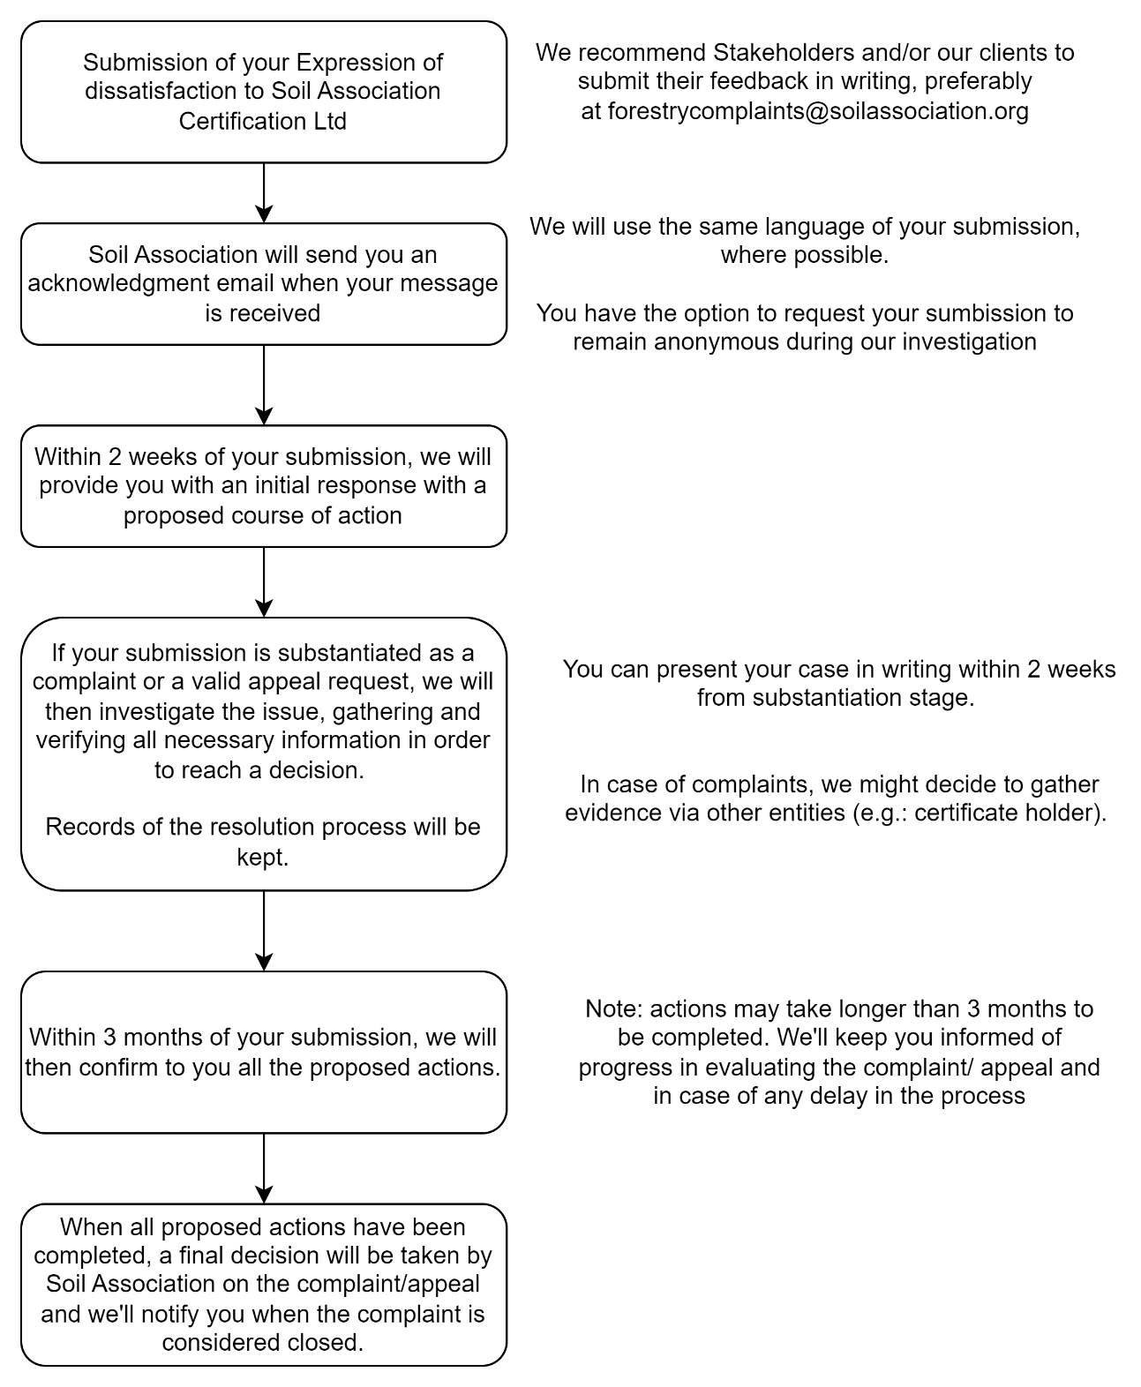

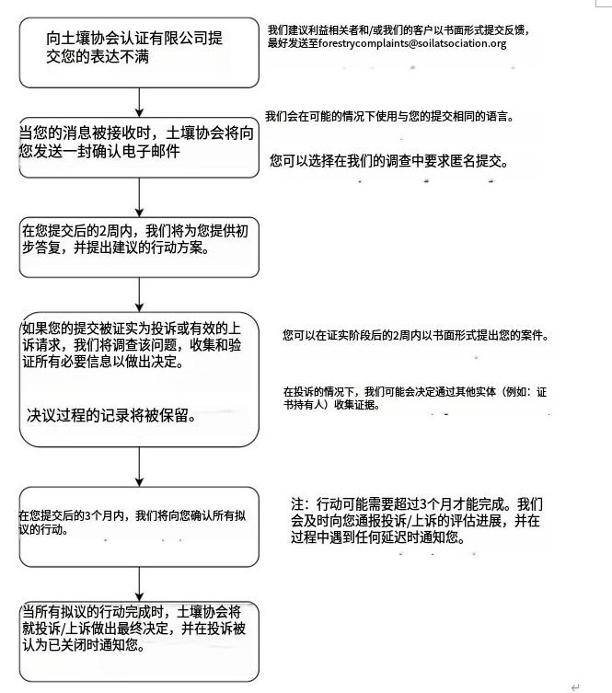

Further Resolution进一步解决
In the case of appeals, further information is available on request in the Soil Association Guidance on appeals process for licensees’ (C277fm). A secondary appeal may be heard by the Certification Scrutiny Committee. 对于申诉，更多信息可参考《土壤协会被许可方申诉流程指南》（C277fm）。二次申诉可由认证审查委员会受理。

If you are not satisfied with Soil Association Certification’s decision:
如果您对土壤协会的决定不满意：

For Forest Stewardship Council® (FSC®) certification issues, you can take your complaint to
对于森林管理委员会®（FSC®）认证问题，您可将投诉提交至：
Assurance Services International GmbH (ASI)
Phone: +49 (228) 227 237 0
Email: asi-info@asi-assurance.org
Website: asi-assurance.org

Assurance Services International GmbH (ASI)
电话：+49 (228) 227 237 0
邮箱：asi-info@asi-assurance.org
网站：asi-assurance.org

Soil Association Certification’s FSC License Code is FSC® A000525.
土壤协会的FSC许可证代码为FSC® A000525。

As the ultimate step the complaint may be referred to FSC International
作为最终步骤，投诉可提交至FSC国际：
Phone: +49 (0) 228 367 66 0
Email: info@fsc.org
Website: fsc.org/en

电话：+49 (0) 228 367 66 0
邮箱：info@fsc.org
网站：fsc.org/en

For Programme of Endorsement of Forest Certification (PEFC) certification issues, you can take your complaint to the PEFC National Office or to PEFC International
对于森林认证体系认可计划（PEFC）认证问题，您可将投诉提交至PEFC国家办公室或PEFC国际：
Phone: +41 (22) 799 4540
Email: info@pefc.org
Website: pefc.org

电话：+41 (22) 799 4540
邮箱：info@pefc.org
网站：pefc.org

Soil Association Certification’s PEFC Licence code is PEFC/ 16-44-917.
土壤协会PEFC许可证代码为PEFC/16-44-917。

4. Contacting Us联系我们

Should you require any further information, please contact us at:
如需更多信息，请联系：

Soil Association Certification - Forestry Team
Spear House, 51 Victoria Street, Bristol, BS1 6AD
Email: forestry@soilassociation.org
Phone: +44 (0)117 914 2435
Website: www.soilassociation.org/forestry

土壤协会 - 林业团队
Spear House, 51 Victoria Street, Bristol, BS1 6AD
邮箱：forestry@soilassociation.org
电话：+44 (0)117 914 2435
网站：www.soilassociation.org/forestry

